
Laufenberg Meats

Processing@laufenbergmarket.com
Processed by Roskum Meats
Luke Laufenberg 608-438-9958

-

BEEF CUTTING INSTRUCTIONS

SIZE | Type | Down Payment
Whole |  | $600
Half | Split – Front - Hind | $300
Quarter | Split – Front - Hind | $150

Front Quarter (circle your choices)
Chuck Roast | 2# or 3# or 4# NONE
Arm Roast | 2# or 3# or 4# NONE
Soup Bones | Yes or No
Rib Eye Steaks ¾” or 1” | 2, 3, or 4 per pkg
Short Ribs | Yes or No Cubes or Racks or Mexican Style
Hind Quarter
T-Bone/Porterhouse Steaks(bone-in) | ¾”, or 1”thick | 2, 3, or 4 per pkg
OR (choose only one)
Tenderloin/New York Strip(boneless) | ¾”, or 1” thick | 2, 3, or 4, per pkg

Round Steak | Regular or Tenderized Cut | ½” or ¾” thick ; 1 per pkg NONE
 | Stew Meat | 1#, 1.5#, 2#, or 3# pkg NONE
 | Cube Steak | 2, 3, 4 per pkg NONE
 | Dried Beef (1#pkgs) or Jerky (1/2# pks) NONE
Rump Roast/ Rolled Rump |  | 2#, 3# or 4# NONE
Sirloin Steak | ¾”, or 1” thick | 1 per pkg NONE
Trimmings: Choose what percentage or pounds of trimmings you want in ground beef or in patties (Examples: 2/3 hamb. & 1/3 patties OR 30# patties & rest hamb.)
Ground Beef _____ ( tubes ___or freezer wrapped___) | 1#, 1.5# or 2#,
Patties _____ ( how many per pkg ____ OR 10# boxes ____) | 1/3 lb. or 1/4 lb. burgers
Miscellaneous – circle if wanted:
Tongue, Heart, Liver, Suet, Oxtail, Flank Steak, Skirt Steak, Brisket (whole or cut in ½)
Processing costs:
Processing Fee = $5.79/lb (cut, Vacuumed Sealed, freeze) Grass-finished = $6.79/lb Tenderizing = $1.00/lb
Patties = $0.85/lb Stew Meat = $1.00/lb Dried Beef = $2.25/lb Jerky = $4.25/lb Prices subject to change without notice.

Name:_______________________________Phone:___________________________________
Address:______________________________________________________________________
Email: ________________________________________________________________________
Other instructions:_____________________________________________________________
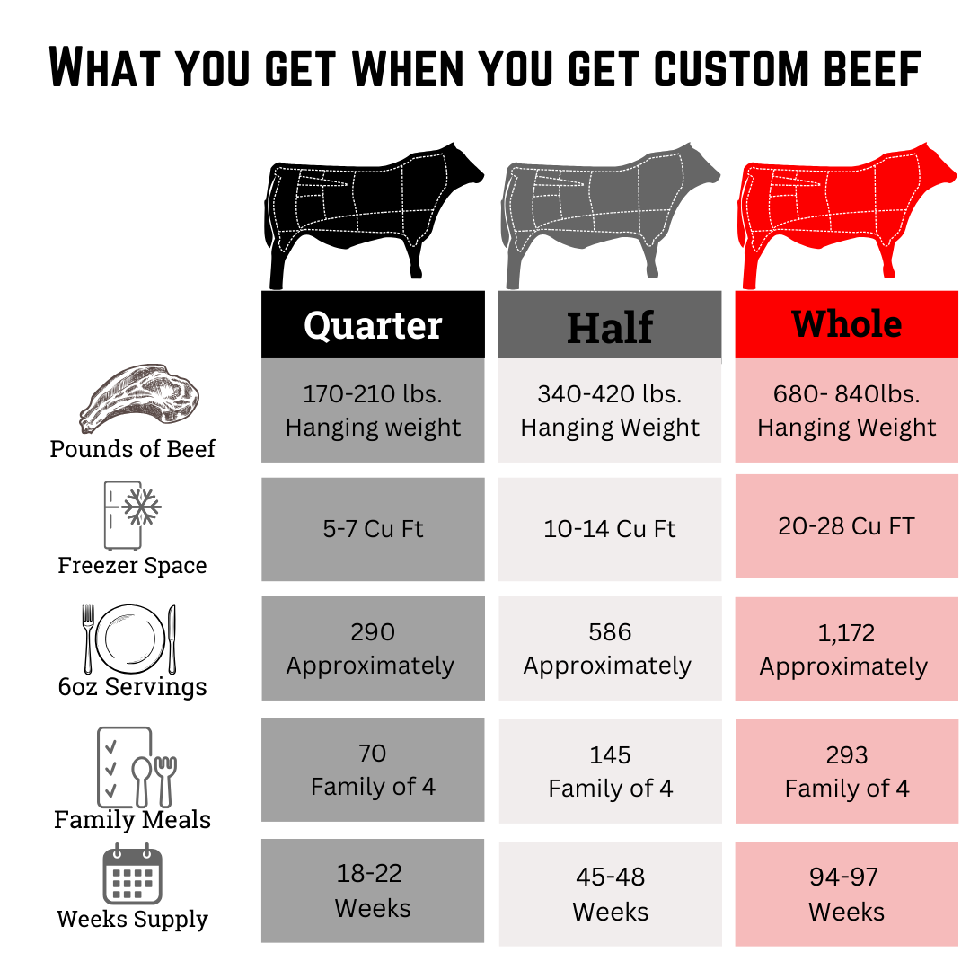
Laufenberg Meats Office Use Only
Order Date:__________________________ Sent To Roskom Date:________________________
Invoice Date:_______________________ Invoice Amount: Cash:____________ Card:____________
Contacted: __________________________________

