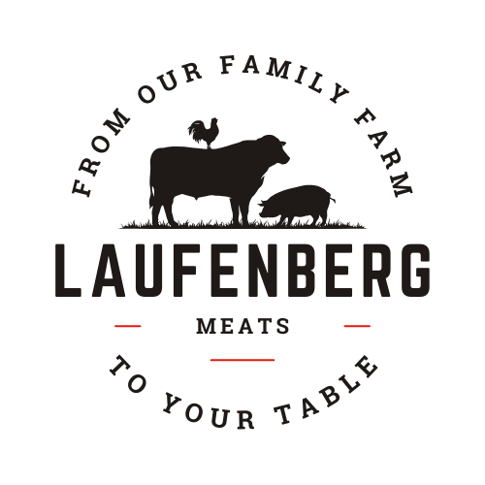

**Laufenberg Meats**

Processing@laufenbergmarket.com

Processed By Roskum Meats

Luke Laufenberg 608-438-9958

6973 Riles Rd. Waunakee WI 53597

***All cuts Vacuum-sealed.***

***PORK CUTTING INSTRUCTIONS***

***Ham - choose fresh PORK ROAST or SMOKED HAM (circle your choices)***

|  |  |  |
| --- | --- | --- |
| Bone-in Ham (smk) | Whole, cut ½, cut 1/3, cut ¼ , 3/4” slices, center slices w/end Rsts | |
| Boneless Ham (smk) | Whole, cut ½, cut 1/3, deli slices(1#pks), ¾” steaks, 1” steaks | |
| Fresh Ham Roast (not smk) | | 2#, 3#, 4#, ¾” steaks, 1” steaks |

***Bacon – choose fresh SIDE PORK or BACON***

|  |  |  |
| --- | --- | --- |
| Smoked Bacon | Y or N | 1# pks, 1.5# pks, 2# pks |
| Fresh Side Pork | Y or N | 1# pks, 1.5# pks, 2# pks |

***Chops, Steaks, Roasts***

|  |  |  |  |
| --- | --- | --- | --- |
| Pork Chops | Y or N | ¾” thick or 1” thick | 2, 3, 4, 5 or 6 per pkg |
| Steaks | Y or N | ¾” thick or 1” thick | 2, 3, or 4 per pkg |
| Roasts | Y or N | 2#, 3# or 4# |  |

***Shanks, Spareribs, Neck Bones***

|  |  |  |  |
| --- | --- | --- | --- |
| Shanks | Y or N | cut or whole | smoked or fresh |
| Spareribs | Y or N | Neck Bones (soup) Y or N | |

***Miscellaneous:*** *Circle the ones you want if available:* Heart, Tongue, Liver, Head, Lard ***Any cut you do not wish to have will be ground into your trimmings*** ***TRIMMINGS: check which one(s) you would like and the amount.***

Examples; ½ links, ¼ brats & ¼ ground pork or 5# brats, rest links

|  |  |  |  |
| --- | --- | --- | --- |
| **Options:** | **Additional cost:** | **Y or N** | **amount** |
| Ground Pork | none |  |  |
| Links | $2.85 lb |  |  |
| Brats | $2.60 lb |  |  |
| Seasoned or Italian Ground Pork (circle which) | $2.30 lb |  |  |
| Breakfast Patties | $2.50 lb |  |  |
| Brat Patties | $2.50 lb |  |  |

***Processing/Smoking costs:***

Processing Fee = $3.49/lb *(cut, wrap, freeze)*

Shanks or Bone in Ham = smoked and cut $1.85/lb Boneless Ham = smoked and cut $2.40/lb

Bacon = smoked and sliced $2.35/lb Side Pork Sliced = $.70 /lb

**Prices may change without prior notice. A down payment is required for custom orders on the date of ordering. We prefer cash or check. When picking up orders, payment can be made with cash, check, or credit card. A 4% service fee applies to all transactions.**

Name_______________________________________________Phone_____________________

Address_________________________________________________________zip____________

Email: ________________________________________________________________________

Portion size: **HALF** or **WHOLE**

Other instructions_______________________________________________________________

____________________________________________________________________________

